**MY VILLAGE**

*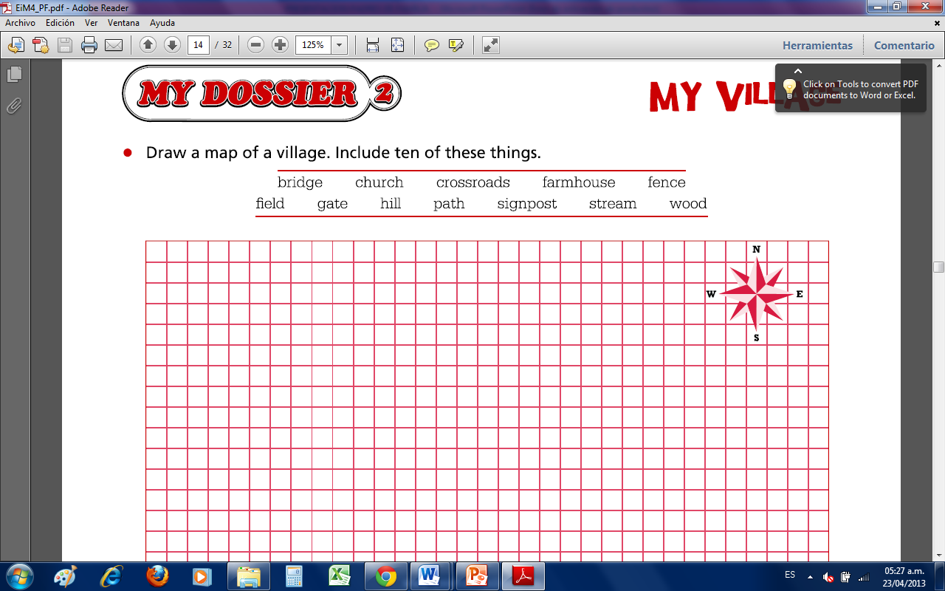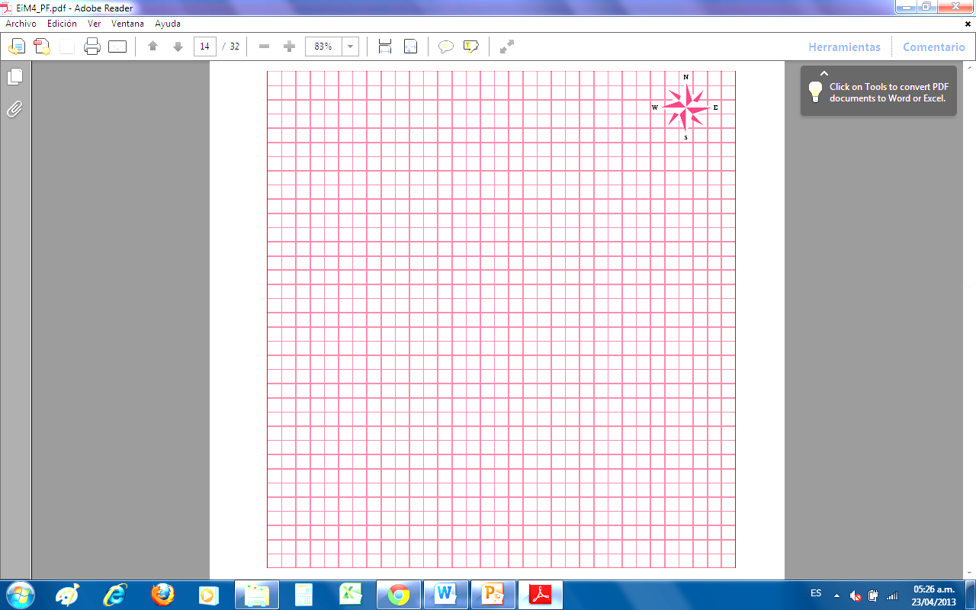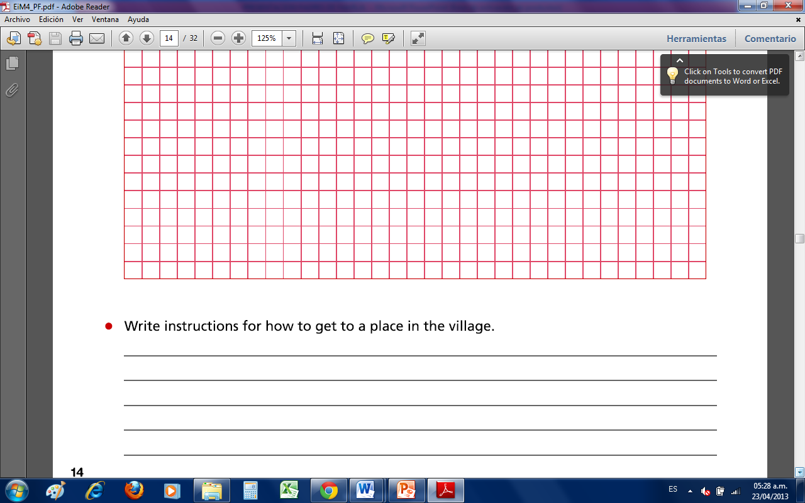Student Names: ________________________________ Grade: ________ Date: ________*